Configuration management tool

1) Devops and Agile relationship- Devops is about bringing operations into agile methodology, and core of it is infrastructure as code.

2) Tools that deals with IAC- Puppet, ansible and chef.

Devops (or) IAAC allow operation to be a developer of their infrastructure.

3) What is IAC- In this technique we create our infrastructure by using some coding technique like-Packer.

4) Infrastructure Lifecyle

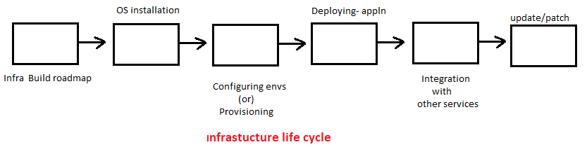

5) Approach to manage infrastructure-

1) First approach to manage infrastructure is manual approach, but later we realize that this concept is not going to work as network grow large. 2) For overcoming of this issue, we come up with a plan called scripting. 3) Later we came up with a plan of golden image (Packer- AMI). 4) Latest approach is IAAC. (</>)

6) Scripting vs IAAC

Scripting- Scripting is way to write step by step task to automate code. Scripting is a procedural way execute the task.

IAAS- In IAAS we focus on output.

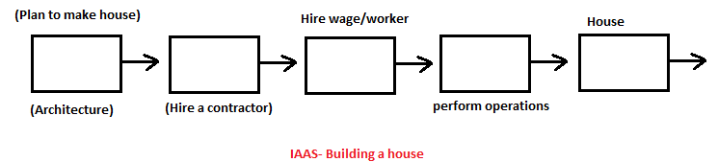

Casestudy- Suppose, you want to make a house then you need to hire architect, who will design infra, and before you start construction home, you will get picture of output, that’s exactly, how infrastructure as code works.

DSL- Domain specific language is a special language that use for a particular suite.

Advantage of IAAC- 1) Migration is very easy, 2) DR environment setup, 3) Absolute consistency.

7) History of Configuration management

* Started in the 1950s by the United States Department of Defense as a technical management discipline
* Process of establishing and maintaining the consistency of something’s functional and physical attributes as well as performance throughout its lifecycle
* Configuration management refers to the process by which all artifacts relevant to your project, and the relationships between them, are stored, retrieved, uniquely identified, and modified.
* This includes the policies, processes, documentation, and tools required to implement this system of consistent performance, functionality, and attributes.

8) Convergence and idempotence behavior: In convergence approach we focus on desire state from current state.

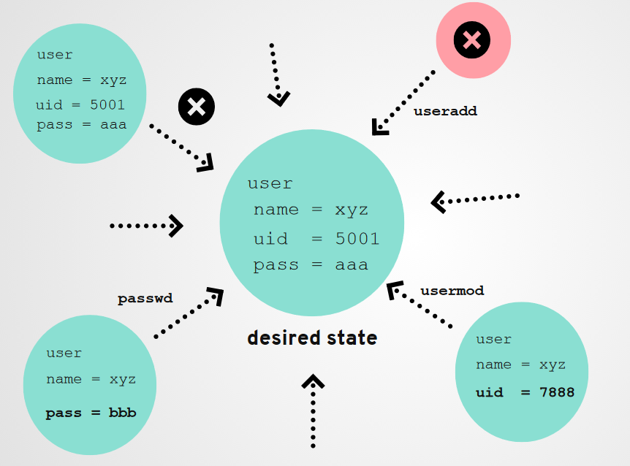

Idempotence: it’s like if we run same command multiple time, it will not impact anything.

Declarative vs Procedural  
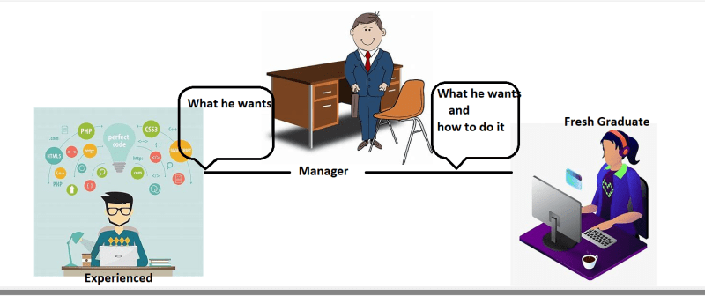  
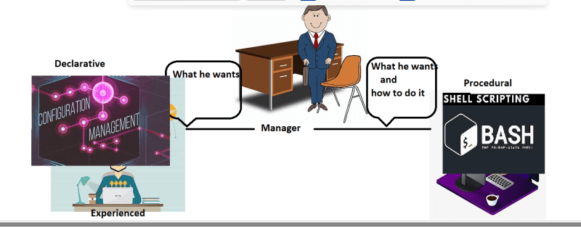

Configuration Management is all about declarative deployment of applications which ensures

* idempotence: Run this once or n times you will have same result
* Desired state: We express configuration to achieve a desired state.